2025-2026 Academic Year
Mercy Health St. Elizabeth Youngstown Hospital
Family Medicine Residents

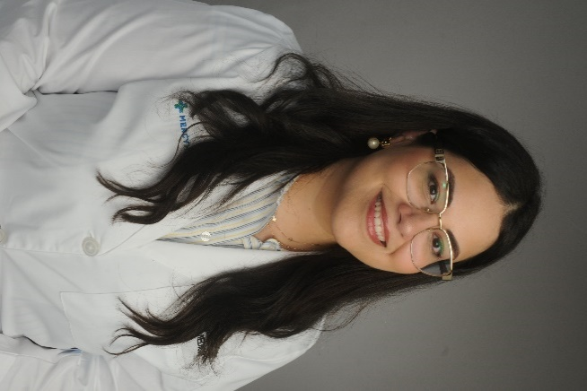

Sylvia Agaibi, MD

PGY 3-Chief Resident

Medical School: American University of Antigua, College of Medicine

Personal interests: Spending time with my family and friends, hiking with my dog, painting, and traveling

Why SEYH? “The people.”
“The program and what it stands for aligns with the values I hold & wanted to be in a program that I could be completely myself in.”
“It’s a very positive and uplifting environment to be in on a daily basis”
“No traffic. No construction. Everything I need is in 15-20 minutes away.”

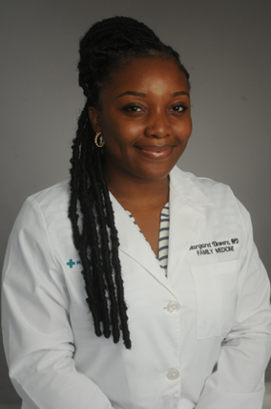

Margaret Ekwere, MD

PGY 3-Chief Resident

Medical School: Windsor University School of Medicine

Personal interests: I love music, reading fictional novels, and watching action movies

Why SEYH? “Top-notch training experience”
“Highly supportive faculty and residents”
“The residents seem truly happy and content to be a part of the program. They all stated how they truly felt like part of a family at SEYH. The faculty were kind and well-rounded.”

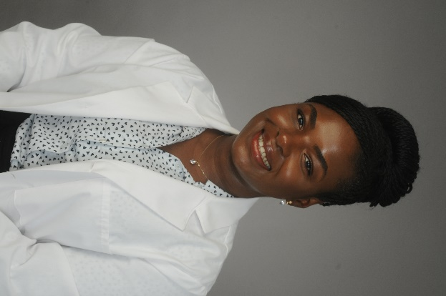

Keshia Enaw Ebob-Tabe, MD

PGY 3-Chief Resident

Medical School: All Saints University School of Medicine, Roseau Dominica

Personal interests: Outdoor nature hiking, biking, cooking, music, dancing, singing, traveling, and learning new languages and cuisines!

Why SEYH? “Amazing faculty and senior residents, who are proficient and love to teach.” “Felt like home…environment was conducive to learning, growth & wellbeing.”
“Our curriculum gives me so much confidence that I will graduate as a proficient primary care provider.”

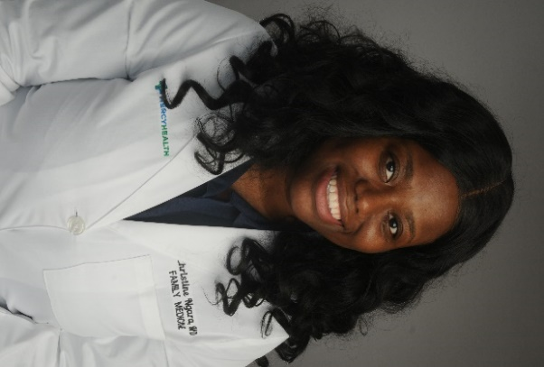

Veronica Danquah, MD
PGY 3

Medical School: American Antigua of Antigua College of Medicine

Personal interests: Creating wellness content for women, cooking traditional Ghanaian meals, travel and skin care enthusiast.

Why SEYH? “The collaborative atmosphere, the diversity of clinical experiences, and the commitment to underserved populations.”
“Residents are encouraged to pursue their interests and develop leadership skills.” “…This is a program where your growth matters. The teaching is intentional, the support is real, and you’ll be part of a team that wants you to thrive.”

Christine Ngara, MD

PGY 3-Chief Resident

Medical School: St. George’s University, Grenada

Personal interests: traveling, reading, dancing and braiding hair

Why SEYH? “How diverse the program is…Separate family medicine orientation block…before you officially start.”
“The fellow residents. Everyone is very supportive of one another and spends time with each other outside of just being colleagues.”

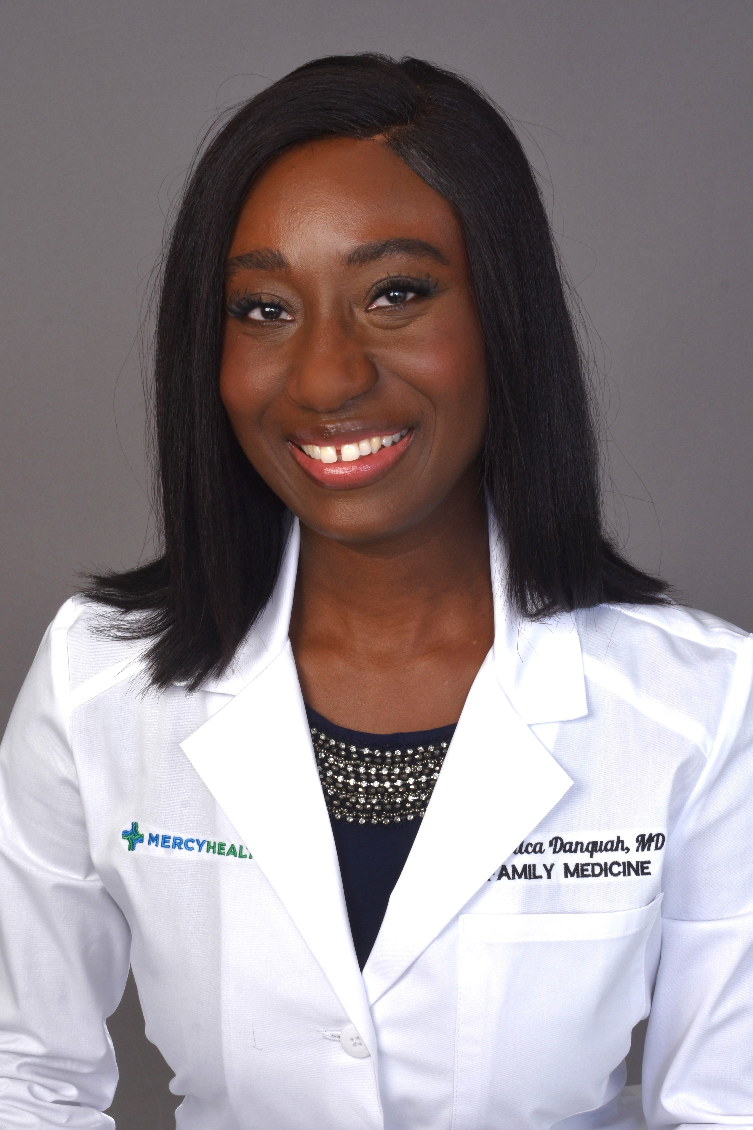

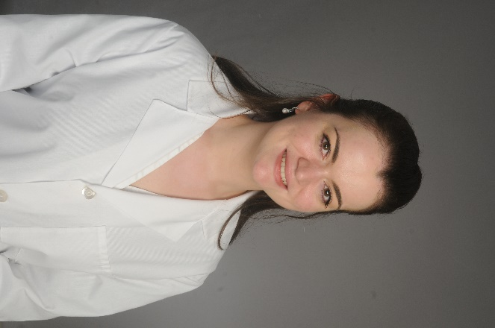
Lucile Chambily, MD

PGY 2

Medical School: Poznan University of Medical Sciences

Personal interests: traveling, discovering new places, spending time with friends, baking, taking care of my plants

Why SEYH? “During the interview, both faculty and residents were incredibly supportive and kind, creating an environment ideal for professional growth and development as a Family Medicine doctor.”
“Opportunity to obtain additional teaching in obesity medicine”
“Supportive environment, comprehensive training, diverse clinical experiences with a wide spectrum of patient cases & procedures, community engagement, and proximity to major cities.”

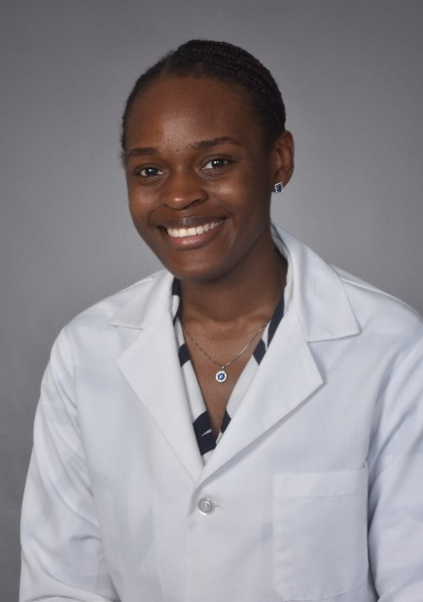

Onyinyechukwu Ezegwui, MD

PGY 2

Medical School: Windsor University School of Medicine

Personal interests: listening to music, watching movies, playing the piano and the guitar

Why SEYH? “I chose this program because of the culture. All the staff were happy to be working at St. Elizabeth. I love the opportunity it provides for community service at the grassroot levels, the high-quality training the program offers residents and the program’s commitment to excellence.”
“It’s a beautiful place to train for residency.”

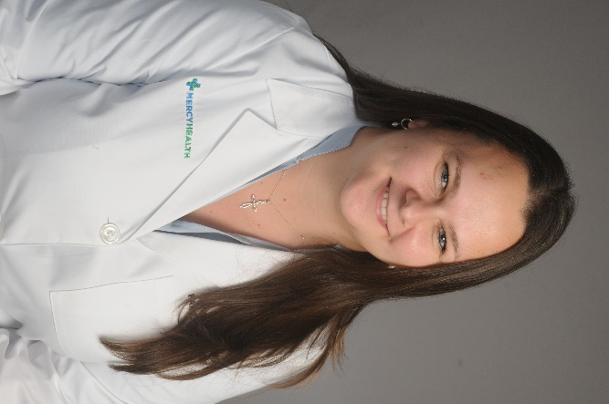

Olena Senyk, MD

PGY 1

Medical School: Poznan University of Medical Sciences

Personal interests: different types of arts and crafts; painting, embroidery, drawing. I love reading and exploring new places, especially cafes and parks.

Why SEYH? “When I was interviewing, I felt like the people here were absolutely amazing. They seemed to genuinely like the program and were open and genuine. I felt that I would truly belong here.”
“The people! Everyone is welcoming and kind. The residents, faculty, and staff are always available and open to help with anything you need.”

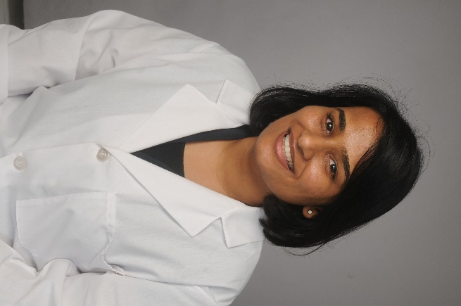

Aishwarya Somani, MD

PGY 1

Medical School: St. Martinus University Faculty of Medicine

Personal interests: playing squash, badminton and pranks on people. I also enjoy spicy food and board games.

Why SEYH? “Diversity is present in every aspect: the people, the work, the complexities of the patients seen. The program prepares you for anything and everything, offering great flexibility in streamlining and focusing on both your professional and personal goals.”
“The transition from medical school to intern year is intense, the support from faculty & fellow residents has made it smooth & manageable.”

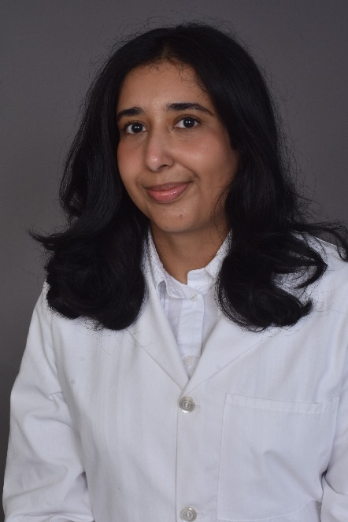
Nazeefa Fatima, MD

PGY 1

Medical School: St. Martinus Faculty of Medicine

Personal interests: Reading fiction especially fantasy, curating music playlists or researching skincare, Pakastani dramas. I also love exploring new coffee shops, travelling or spending time outdoors with my husband!

Why SEYH? “It was evident that the faculty are deeply committed to the well-being and success of their residents, as well as to training exemplary physicians.”
“The best part is the support…the faculty members are inspiring and encouraging; they are passionate about teaching and mentoring while setting a high standard for compassionate, patient-centered care. Moreover, it truly feels like a team environment, as my fellow residents are supportive, collaborative, and incredible people!”

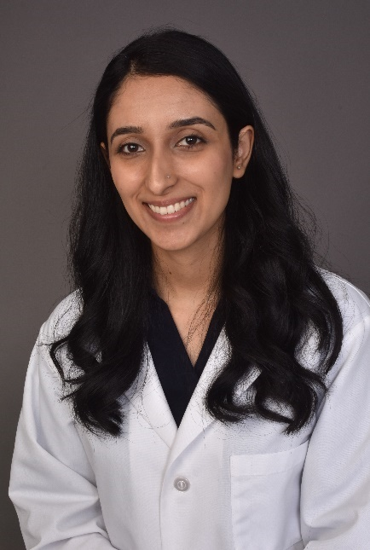
Jaweria Naz Kiani, MD

PGY 1

Medical School: Shifa College of Medicine

Personal interests: Vlogging, hair styling, reading

Why SEYH? “The residents seemed really happy with the program.”
“…The St. Elizabeth Family Medicine Residency strikes a nice balance between strong academics and a good work-life balance.”
“Youngstown is close to major cities, so you get the best of both suburban and urban lifestyles. The patient population is incredibly diverse, not just in background but also in the range of medical conditions that you see which makes for great learning.”

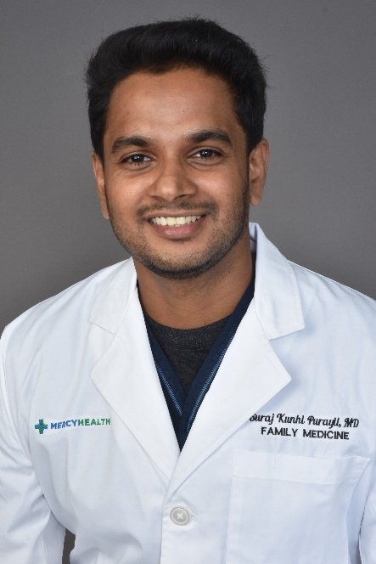
Suraj Kunhi Purayil, MD

PGY 1

Medical School: St. Martinus University Faculty of Medicine Curacao

Personal interests: soccer, stock market trading, and astronomy

Why SEYH? “The program has a well-organized training, and everyone feels like a family. This makes learning easier and more comfortable because everyone helps each other and supports each other.”

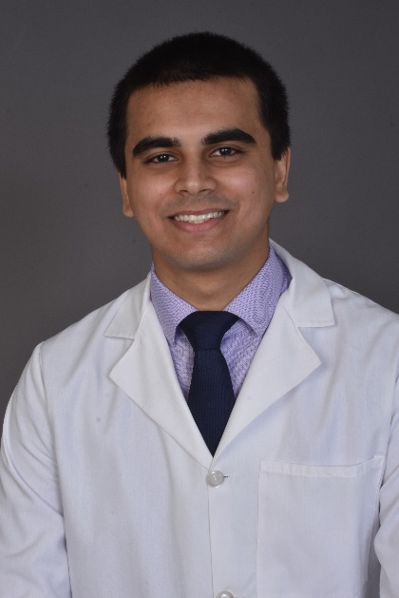
Aditya Rai, MD

PGY 1

Medical School: Sri Lakshmi Narayana Institute of Medical Sciences

Personal interests: Swimming, gym, history, geography, space & aviation, cooking, PC gaming

Why SEYH? “Aside from having manageable hours, great learning resources and very interesting rotations, it has to be the people that you work with. Having only a few residents for each year means that everybody knows everyone else and it builds camaraderie among the residents, the faculty and the attending physicians. They whole program is incredibly welcoming and helpful. They make you want to improve and be a better physician.”

